How to Connect ECTACO® Partner® LUX to your PC

Installing the Driver

You need to install the appropriate USB driver to connect ECTACO® Partner® LUX to a Windows-powered computer.

Download the http://www.ectaco.com/products/materials/1/usb_driver.zip archive to your computer and then unpack it.

Once you have downloaded and unpacked the archive, follow the instructions below to install the driver, depending on the operating system edition you are using.

Windows 7
- Connect your ECTACO® Partner® LUX to your computer's USB port.
- Right-click on Computer from your Desktop or Windows Explorer and select Manage.
- Select Devices in the left pane.
- Locate and expand Other device in the right pane.
- Right-click the device name (such as ECTACO LUX UMS USB Device) and select Update Driver Software. This will launch the Hardware Update Wizard.
- Select Browse my computer for driver software and click Next.
- Click Browse and locate the USB driver folder, i.e. the folder to which you unpacked the "usb_driver.zip" archive.
- Click Next to install the driver.

Windows Vista
- Connect your ECTACO® Partner® LUX to your computer's USB port. Windows will detect the device and launch the Found New Hardware wizard.
- Select Locate and install driver software.
- Select Don't search online.
- Select I don't have the disk. Show me other options.
- Select Browse my computer for driver software.
- Click Browse and locate the USB driver folder, i.e. the folder to which you unpacked the "usb_driver.zip" archive. As long as you specified the exact location of the driver, you may leave Include subfolders checked or unchecked – it doesn't matter.
- Click Next. Vista may prompt you to confirm the privilege elevation required for driver installation. Confirm it.
- When Vista asks if you'd like to install the Google ADB Interface device, click Install to install the driver.

Windows XP
- Connect your ECTACO® Partner® LUX to your computer's USB port. Windows will detect the device and launch the Hardware Update Wizard.
- Select Install from a list or specific location and click Next.
- Select Search for the best driver in these locations, un-check Search removable media and check Include this location in the search.
- Click Browse and locate the USB driver folder, i.e. the folder to which you unpacked the "usb_driver.zip" archive.
- Click Next to install the driver.

Using microSD Card

After the driver is installed, you can access a microSD card.
- Slide the card into the microSD slot on the device – the contacts of the card face up. Push the card gently until it clicks into place.
- Make sure the device is on.
- Connect ECTACO® Partner® LUX to your PC using the USB cable. Please wait while your PC detects the device.
- In the dialog box that appears on the screen of your ECTACO® Partner® LUX, tap Turn on USB storage.

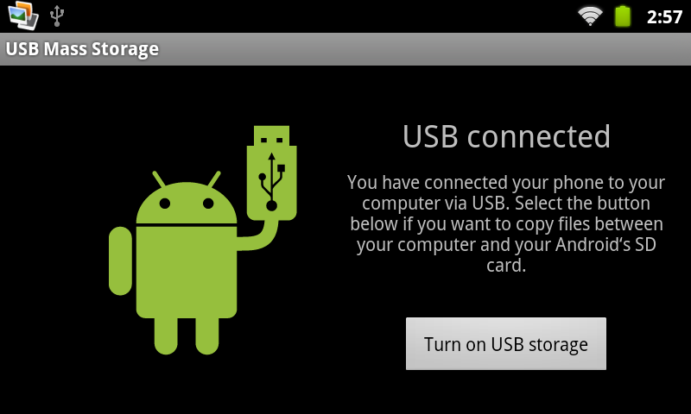
- Navigate to the newly detected removable disk on your PC to browse through the files stored on the microSD card.

